**Practical No 12**

**Description:**

A web application performance tool (WAPT) is used to test web applications and web related interfaces. These tools are used for performance, load and stress testing of web applications, web sites, web API, web servers and other web interfaces.

**Aim: To perform the load testing and stress testing using WAPT.**

**Theory:**

**A) Load Testing**

Load Testing is a non-functional software testing process in which the performance of software application is tested under a specific expected load. It determines how the software application behaves while being accessed by multiple users simultaneously. The goal of Load Testing is to improve performance bottlenecks and to ensure stability and smooth functioning of software application before deployment.

**Why Load Testing?**

- Load testing gives confidence in the system & its reliability and performance.

- Load Testing helps identify the bottlenecks in the system under heavy user stress scenarios before they happen in a production environment.

- Load testing gives excellent protection against poor performance and accommodates complementary strategies for performance management and monitoring of a production environment.

**Goals of Load Testing:**

Response time for each transaction. Performance of System components under various loads. Performance of Database components under different loads. Network delay between the client and the server. Software design issues. Server configuration issues like a Web server, application server, database server etc. Hardware limitation issues like CPU maximization, memory limitations, network bottleneck, etc. Load testing will determine whether the system needs to be fine-tuned or modification of hardware and software is required to improve performance.

**Process of Load Testing**

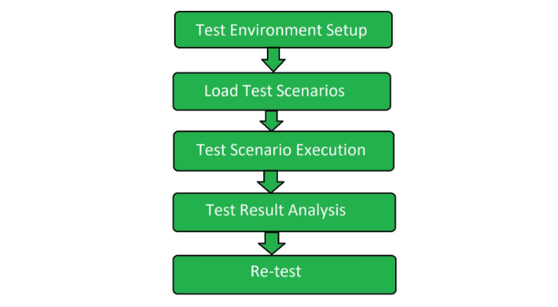

**B) Stress Testing**

Stress Testing is a type of software testing that verifies stability & reliability of software application. The goal of Stress testing is measuring software on its robustness and error handling capabilities under extremely heavy load conditions and ensuring that software doesn't crash under crunch situations. It even tests beyond normal operating points and evaluates how software works under extreme conditions.

**Stress testing is also extremely valuable for the following reasons:**

- To check whether the system works under abnormal conditions.

- Displaying appropriate error message when the system is under stress.

- System failure under extreme conditions could result in enormous revenue loss

- It is better to be prepared for extreme conditions by executing Stress Testing.

**Goals of Stress Testing:**

The goal of stress testing is to analyse the behaviour of the system after a failure. For stress testing to be successful, a system should display an appropriate error message while it is under extreme conditions. To conduct Stress Testing, sometimes, massive data sets may be used which may get lost during Stress Testing. Testers should not lose this security-related data while doing stress testing. The main purpose of stress testing is to make sure that the system recovers after failure which is called as recoverability.

**Process of Stress Testing**

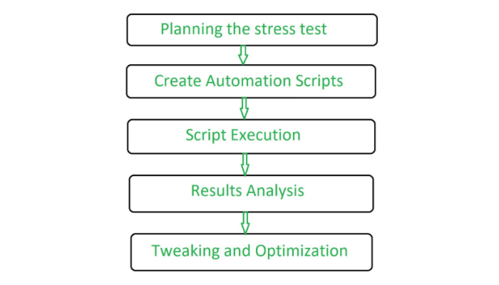

**WAPT Pro test screenshots :**

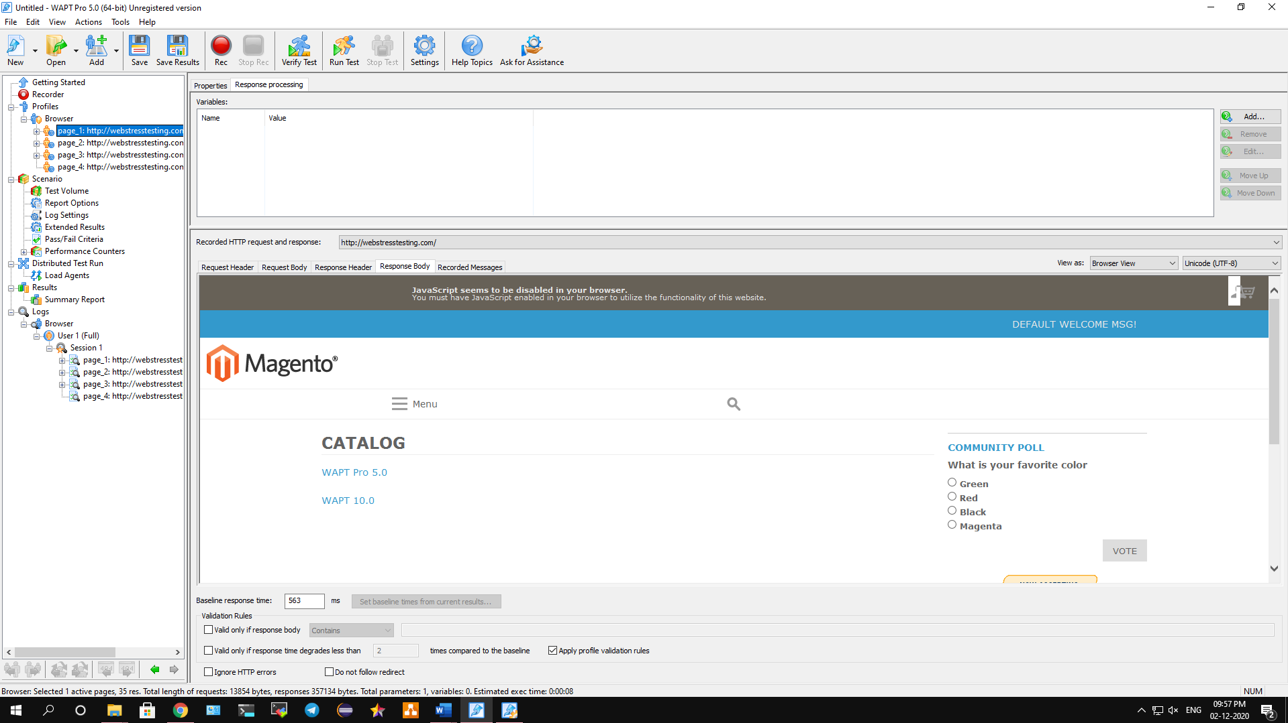

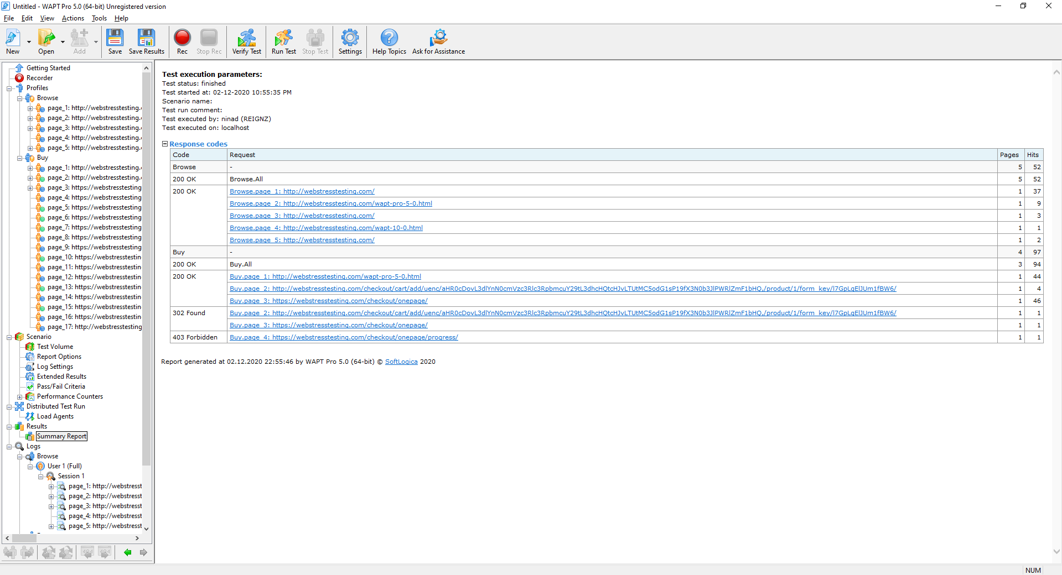

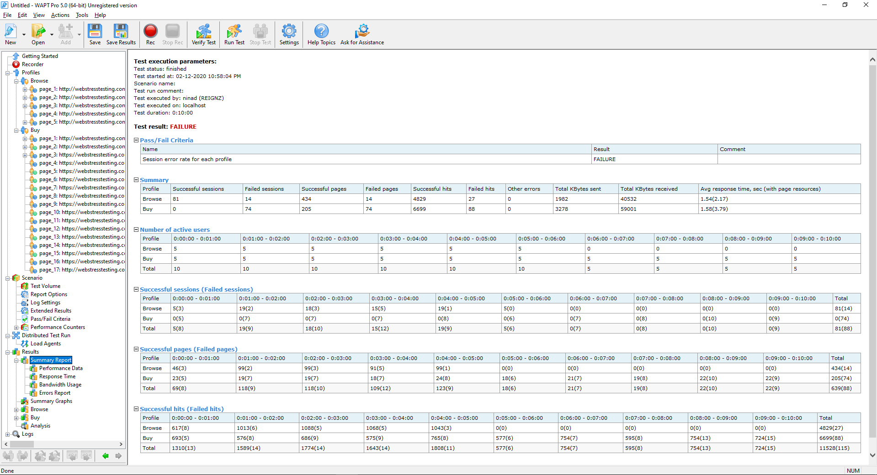

**Summary Report**

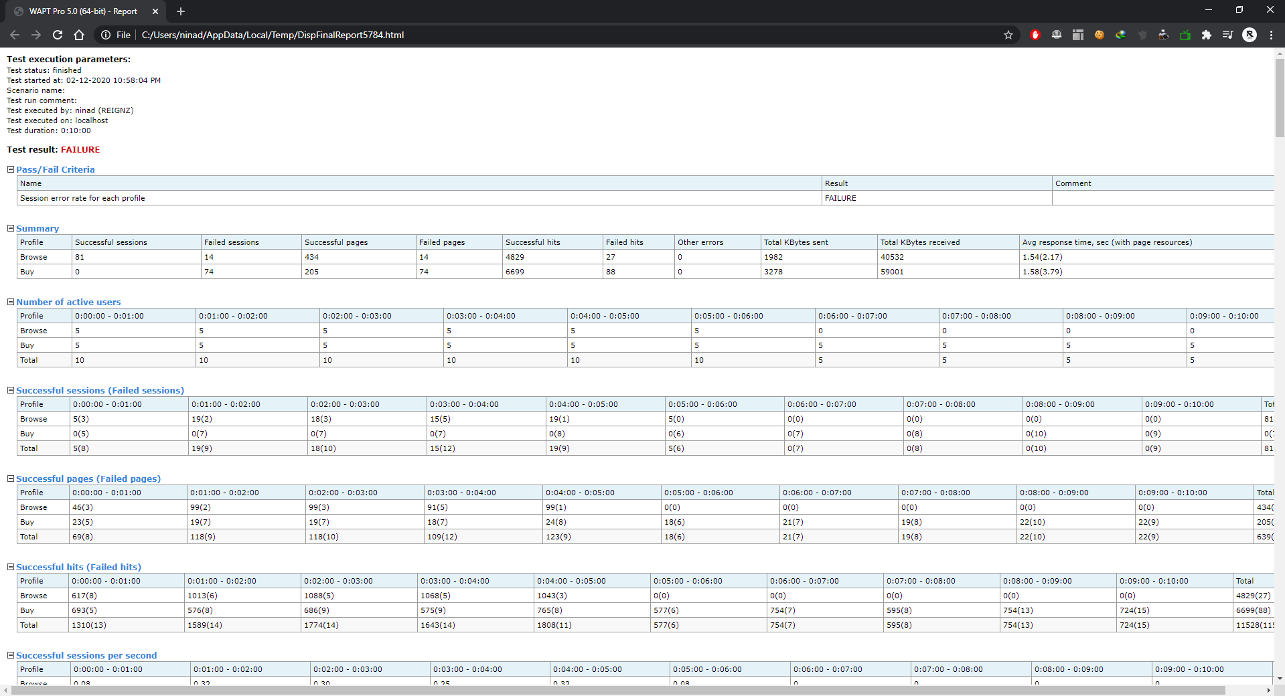

**Graph**

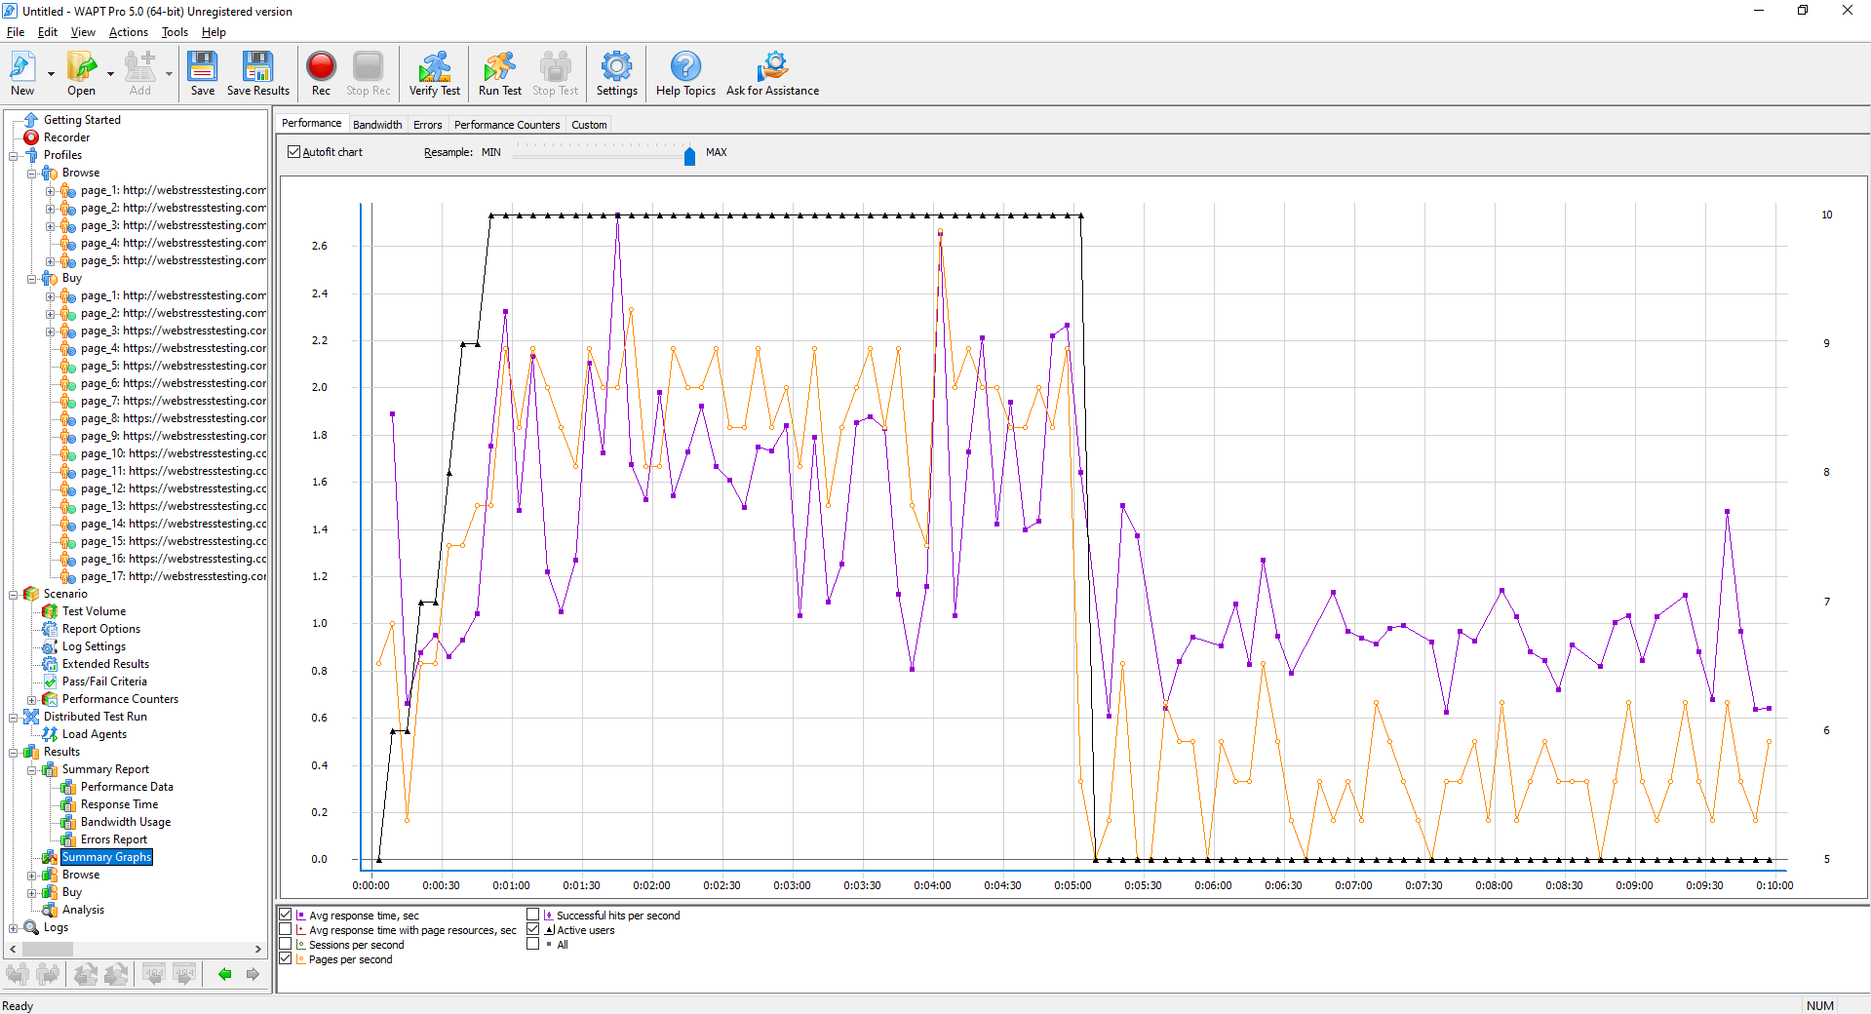

**Conclusion: We have performed the Load Testing and Stress Testing using WAPT.**